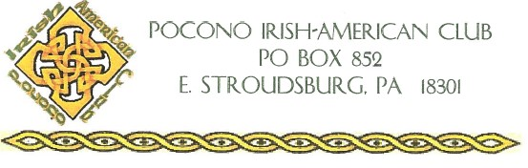

Pocono Irish American Club Special Needs Scholarship (Students with Intellectual Disabilities) Application

Applicants must be a
- Monroe County Resident
- 17 years of age or older
- Looking to attend college or technical school
- Answer all question on the application form
- Supply two (2) letters of recommendation (Cannot be from a family member or Club member)
- Complete application to be returned by email to piacscholarship@gmail.com no later than midnight May 1st
- Parent/Gradians name and contact information

Application Questions

- Applicant’s name and address and contact phone number
- What school or programs do you plan on attending?
- What are your hobbies?
- Tell us about your family.
- Tell us something you know about being Irish or St. Patrick.
- Tell us something you don’t know about you?

