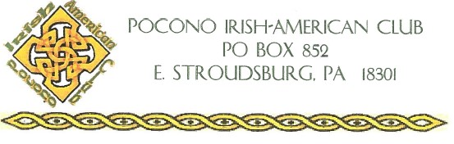

SCHOLARSHIP APPLICATION FORM 2023
Please Print Clearly
Student Name:_____________________________________ Age: ________________
Address: _______________________________________________________________
Phone Number: _______________________ Email: _____________________________
Parent/Guardian Name(s): _________________________________________________
Name of High School Attending: _____________________________________________
Name of College you will attend: _____________________________________________

PLEASE ATTACH THE FOLLOWING INFORMATION TO THIS APPLICATION:
- 500-700-word essay on “What your Irish Ancestry and heritage means to you?”
- Resume, including scholastic qualifications, activities, community service, hobbies, and employment.
- Two letters of recommendations. (Cannot be family members or Club members)
- Copy of most recent Student Transcript.

PLEASE EMAIL COMPLETED APPLICATION TO:
piacscholarship@gmail.com

Pocono Irish American Club will award two (2) $1500 college scholarships
Scholarship Application Guidelines for the College Scholarships are as follows:
Applicants must be:
- Monroe County Resident
- High School Senior
- GPA 3.0 or higher
- Irish Descendent
- Attending College in Fall 2023

Application is due no later than May 1, 2023

Late or incomplete applications will not be considered

