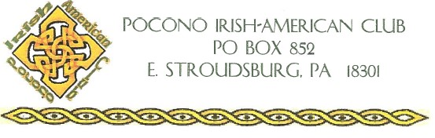
The Ken Corcoran Memorial Scholarship.
Pocono Irish American Club will award one (1) vocational school scholarship, The Ken Corcoran Memorial Scholarship.
Scholarship Application Guidelines for the College Scholarships are as follows:
Applicants must be:
- Monroe County Resident
- High School Graduate/GED
- Between the ages of 18 and 22
- Irish Descendent
- Attending Vocational/Technical School in Fall 2023

Application is due no later than May 1, 2023

Late or incomplete applications will not be considered

SCHOLARSHIP APPLICATION FORM 2023
Please Print Clearly
Student Name:_____________________________________ Age: ________________
Address: _______________________________________________________________
Phone Number: _______________________ Email: _____________________________
Parent/Guardian Name(s): _________________________________________________
Name of High School Attending: _____________________________________________
Name of College you will attend: _____________________________________________

PLEASE ATTACH THE FOLLOWING INFORMATION TO THIS APPLICATION:
- 500-700-word essay on “What your Irish Ancestry and heritage means to you?”
- Resume, including scholastic qualifications, activities, community service, hobbies, and employment.
- Two letters of recommendations. (Cannot be family members or Club members)
- Copy of most recent Student Transcript.

